Chapter 3
RESPONSIBILITIES

References
  - SPPM 2.10 Accident Prevention Responsibility
  - SPPM 2.24 Accident Reporting and Follow-Up
  - WAC 296-800-110 Employer Responsibilities: Safe Workplace
  - WAC 296-800-120 & 12005 Employee Responsibilities
  - HRS Alcohol and Drug Abuse Manager Guidelines
  - Exec Policy #20 Alcohol and Drug Policy
  - Hazard Assessment Form

Introduction
The responsibility to maintain a safe workplace, resides with each employee, for themselves, their peers and the public. That responsibility includes the elimination of hazards wherever possible, and reporting actual or potential hazards immediately upon their observation. Specific safety responsibilities are identified in this Chapter’s subsequent sections and further discussed where applicable.

IN SITUATIONS WHERE IMMINENT DANGER OR SERIOUS HAZARD(S) EXIST(S), ANY EMPLOYEE HAS THE AUTHORITY TO CEASE WORK UNTIL THE DANGER OR HAZARD HAS BEEN CONTROLLED.

Directors
Directors ensure employees in their units adhere to State rules, WSU and departmental safety policy. Directors must coordinate and manage safety responsibilities with their supervisors and employees as appropriate to effectively implement safety policies. Safety performance shall be specifically addressed in position descriptions and performance evaluations.

Directors shall:
- Administer the Safety Program for their unit.
- Adopt this APP and provide input/revision as necessary to address/incorporate unique unit requirements while adhering to State rules.
- Solicit input from subject matter experts ensuring Departmental policies are aligned with State requirements.
- Ensure supervisors implement Department safety policies per this APP.
- Ensure supervisors perform and document Hazard Assessments and identify the resources necessary to provide appropriate engineering and administrative controls and/or Personal Protective Equipment (PPE) to unit personnel.
- Disseminate safety information to appropriate personnel.
- Receive and review reports, surveys, accident reports, and other information relating to safety and loss control.
- Review injury trends and establish prevention measures.
- Review and/or conduct incident investigations and inspections.
- Evaluate the need for corrections to remedy or improve various workplace safety concerns, allocate necessary resources and ensure the remedy is implemented and maintained.
- Ensure appropriate participation in Department Safety Committee meetings.

Supervisors
Supervisors ensure their employees adhere to safety policies and are provided the necessary training and resources to perform work safely. Supervisors are accountable to the director for adherence to relevant safety policies and objectives. Safety performance shall be specifically addressed in position descriptions and performance evaluations.

Supervisors shall:
- Ensure safety policies and procedures are understood and implemented by themselves and their employees.
- Promote employee participation in the health and safety program.
- Perform and document Hazard Assessments of work areas under their control and tasks performed by their employees. Hazard assessments shall identify the engineering and administrative controls and/or PPE necessary to perform work safely.
- Ensure their employees receive the required and necessary training to implement hazard controls and wear PPE.
- Require the proper care and use of PPE.
- Eliminate or control workplace hazards quickly when observed or identified to them by their employees.
- Report to the Director workplace hazards observed or identified to them by their employees that are outside their ability or require additional resources to control.
- Review injury trends and establish prevention measures.
- Submit incident reports and conduct supervisor’s incident investigations when employees sustain a workplace injury or are subject to a significant near miss.
- Act to secure prompt medical attention for injured persons.
- Enforce the conditions of WSU’s Return to Work policy.

Employees
Employees actively participate in Department health and safety programs, familiarize themselves with WSU and Departmental safety policies, and work with their supervisors and coworkers to control or eliminate workplace hazards. Employees have the right and responsibility to refuse unsafe work. Employee safety performance shall be specifically addressed in position descriptions and during performance evaluations.

Employees shall:
- Review, understand, and adhere to State safety rules and WSU and Departmental safety policies, including this APP.
- Strive to make all work environments and operations safe.
- Report for work in good physical and mental condition to safely carry out assigned duties.
- Keep all work areas clean and free of debris and obstacles.
- Request assistance or training when unsure of how to perform any task safely.
- Correct unsafe conditions within their scope of work.
- Report observed safety and health violations, suspected violations, and anticipated hazards to his or her immediate supervisor immediately upon observation or detection. If such reported conditions are not subsequently corrected, the employee is to report the failed correction to their Supervisor or the Director for further action.
- Proactively and constructively participate in safety training.
- Pass verification testing in all mandatory safety training prior to performing work.
- Use and maintain all PPE and safety devices provided.
- Maintain and properly use all tools under his or her control.
- Assist fellow employees in implementing safety procedures and adhering to safety requirements.
- Not interfere with another employee's use of any safety device or safeguard.
- Not use intoxicating beverages or narcotics in or around the workplace or enter the workplace while under the influence of intoxicating beverages or narcotics.

F. Safety Compliance
  - Purpose: Compliance with all safety rules and procedures is a condition of employment when working for CAHNRS. All employees must familiarize themselves with University and Department safety policies and procedures, and comply with them in every respect. Supervisory personnel at all levels are responsible for taking immediate corrective action when an unsafe action is observed.

  - Reporting: If non-compliant behavior or conditions are observed, or come to the attention of any employee, immediate action shall be taken to correct the non-compliant behavior or condition and the employee’s supervisor shall be notified.

  - Labor and Industries Site Inspection: If a Washington State Department of Labor & Industries Division of Occupational Safety and Health (L&I/DOSH) inspector arrives at your work location in Pullman to conduct a safety and health inspection, immediately contact your supervisor who in turn will contact their chain of command and contact WSU Environmental Health & Safety (EH&S) at 335-3041. If not on site when the inspector arrives, the immediate supervisor will go to the site as soon as notified. If on site, the supervisor will remain on site while the inspector is present. EH&S serves as the L&I/DOSH coordinating liaison for WSU and will assist with the inspection process.

  - Investigation: The supervisor shall immediately conduct an investigation and document the results.
  - Action: Failure to comply with safety policies and procedures is to be considered serious and will result in timely corrective or disciplinary action judged to be appropriate for the specific circumstances at hand. Progressive corrective/disciplinary action is appropriate for addressing non-compliance issues, recognizing that more serious offenses do not necessarily require that intermediate steps be taken first. Questions concerning appropriate corrective or disciplinary action should be addressed to the appropriate Director/Manager or Human Resource Services.

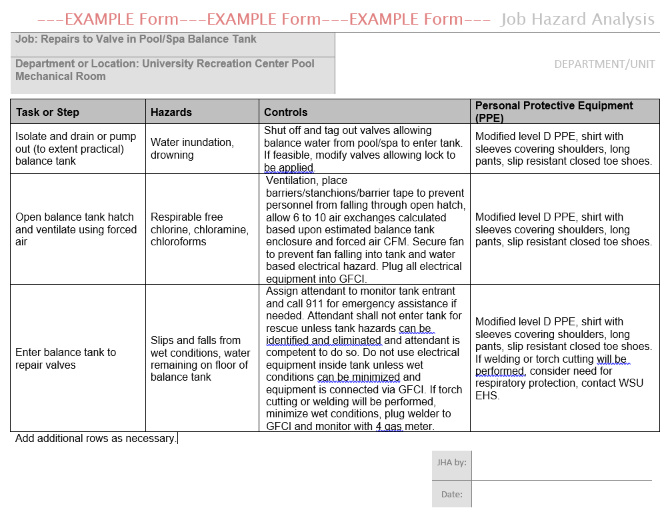
APPENDIX A: Job Hazard Analysis Form Example

Instructions:
Use this basic form “as is” to identify hazards, controls, and PPE at the job task (or step) level. You can modify the form to meet any additional needs of your workplace. JHA hazard information can be used to develop separate safe work procedures for employee use.

Job: You need to first select a job (or main activity) to observe and analyze.

Tasks or Steps: List tasks or steps that are part of the job you selected in the “Task” column.
Example: “Operating a table saw” would be the job while “Installing a blade” and “Ripping” would be separate tasks.

Hazards: Note any condition in the workplace that can potentially cause occupational injury, death, or disease. Assume that no personal protective equipment is being worn- even if it is because hazards could persist if PPE isn’t used. You may choose to add detail about how injuries could occur due to the hazard.
Examples of hazards include: working at heights, slippery surfaces, exposed moving machinery parts, fire, explosion, noise, electricity, toxic emissions, corrosive chemicals, low oxygen, repetitive tasks, heavy lifting, infectious Bloodborne pathogens, etc..
Examples of how injuries can occur: work at height can result in falls that can result in broken bones, paralysis, or death; noise exposure can cause permanent and severe ringing in the ears and hearing loss; exposure to corrosive chemicals can cause permanent skin damage and blindness; and working in low oxygen areas can lead to sudden suffocation, unconsciousness, and death.

Controls: Note how you will eliminate or minimize the hazard. This doesn’t include PPE.
Examples of controls include: Using a safer tool or equipment or chemical, adding safeguards to machinery, using safer work practices, using local exhaust ventilation for toxic emissions, and enclosing noisy equipment or moving workers away from such equipment to reduce exposure levels.

PPE (Personal Protective Equipment): Detail what type of PPE is needed for each hazard that can’t be eliminated or minimized using controls.

